TRACKING ADDICTION TRENDS USING SOCIAL MEDIA
Objectives - Track geographic spread of addiction trends
Data Sources - Twitter/X, Reddit, TikTok comments, Facebook/Instagram
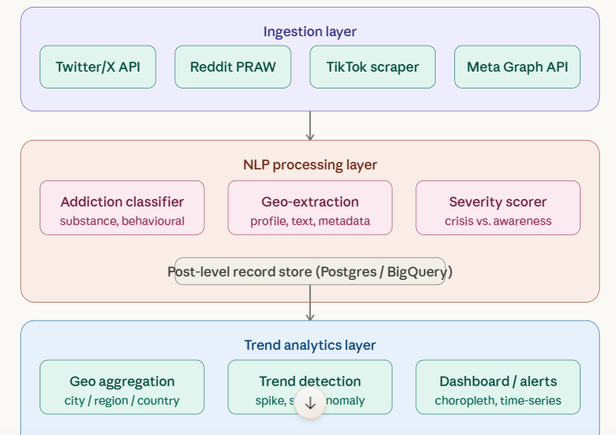

Tools: VS code, Git bash
Trend aggregator — groups posts by region and time window
Anomaly detector — flags geographic spikes
Dashboard — choropleth map + time series charts

